# Story Title

## November 2016

## 07468524364 ~ www.youngandfreecharity.co.uk ~ l.whittle@youngandfreecharity.co.uk

Story Subtitle or summary

Hi everyone,

Sorry it’s taken so long for a newsletter to be put together but as you may know it’s been a very busy time here at Young and Free, 1 of the highlights was a weekend break to Calvert trust which we will be talking about in detail shortly.

It will also feature the events we have planned for the rest of 2016.

Hope you enjoy this issue.

Laura ☺

# Story Title

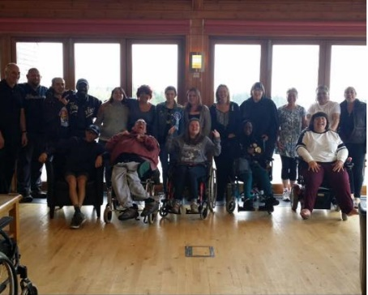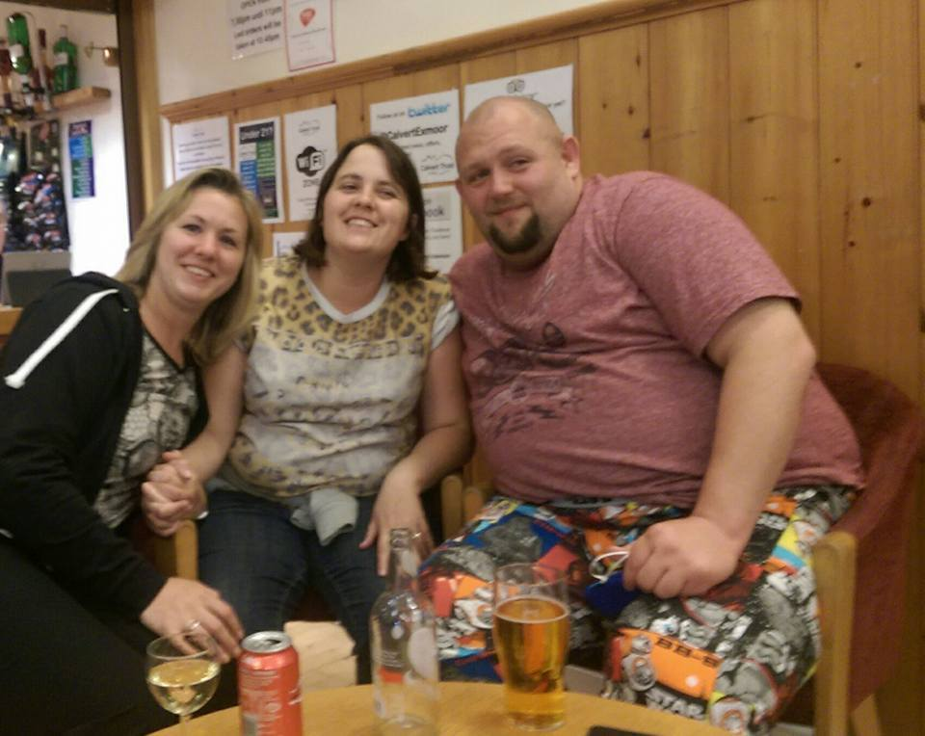Story Subtitle or summary

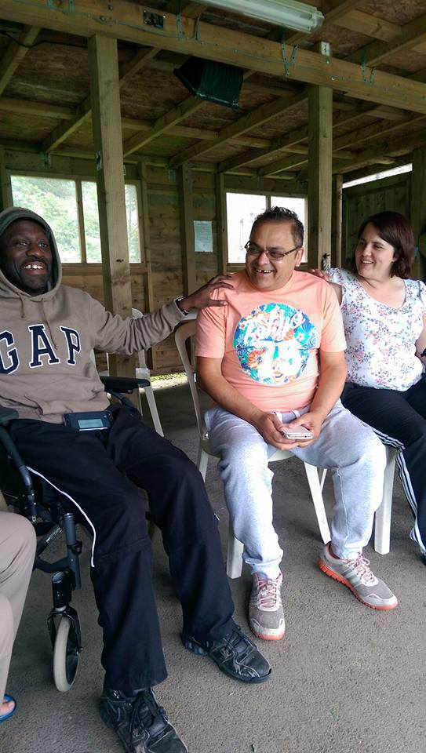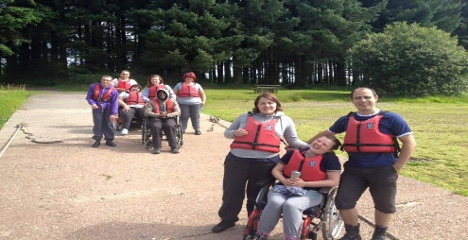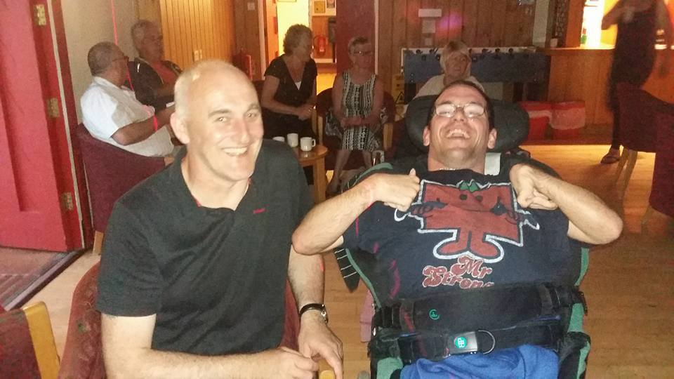

In late July members and volunteers of Young and Free enjoyed our second trip to the Calvert trust in Exmoor. It was a huge success once again thanks to the support of our team of volunteers and the helpful staff members and instructors at the Calvert Trust, it was great to see everyone having such a great time and challenging themselves to try now sports and activities.

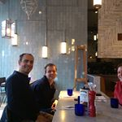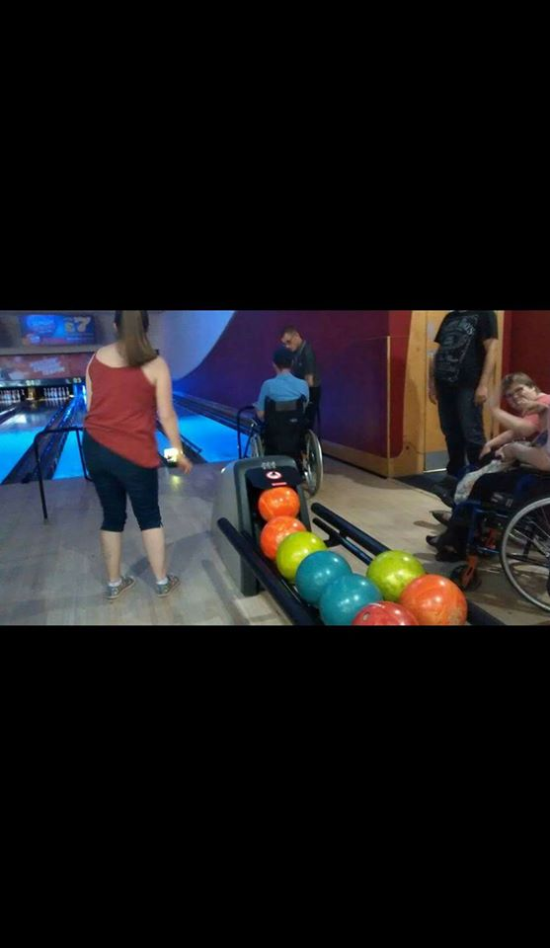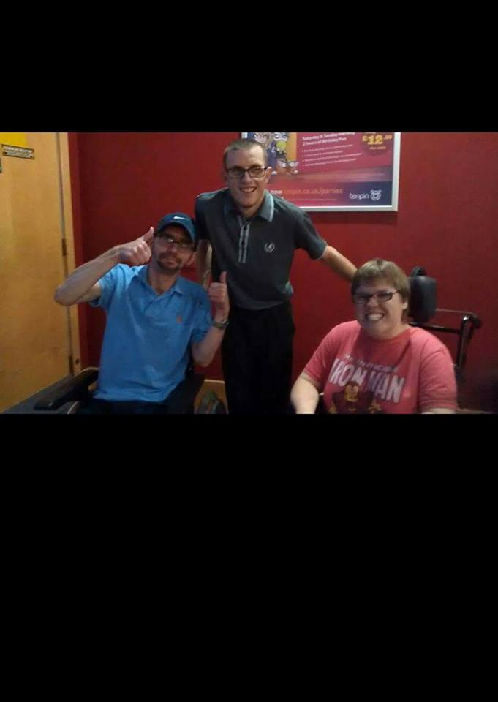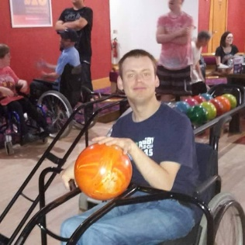

As you may already know we are looking for sponsorship to help us print and distribute a photo calendar featuring our event photos to raise funds for the charity.

If you have any suggestions of businesses to approach for support contact Laura on: 07468524364 or email l.whittle@youngandfreecharity.co.uk

@Yandfbristol

**Upcoming events**

* Sunday 30th October – Halloween disco @ Filwood
* Sunday 20th November – day out at slimbridge bird sanctuary
* Sunday 27th November – Christmas card making afternoon at filwood community centre
* Friday 2nd December – Christmas meal at the black castle avonmeads

As well as this we’ve recently had a quiz afternoon and a meal event at pizza express Cabot circus.

Jumping to September we had a bowling event at tenpin avonmeads which is always a popular event plus a trip to McDonald’s afterwards.